Project Development Phase
Performance Test

Date | 27 October 2026
Team ID | Individual
Project Name | Global Olympic Sports Performance Analysis
Maximum Marks

Project Performance Testing:
Project team shall fill the following information in model performance testing template.
S.No. | Parameter | Screenshot / Values
1 | Data Rendered | Sources loaded in Tableau: athletes.csv (8,000 rows), games_summary.csv (18 rows), medal_results.csv (910 rows), alltime_country_rankings.csv (60 rows). Sheet 1 renders 60 marks (60 rows by 1 column) with SUM(Total Medals) = 6,025.  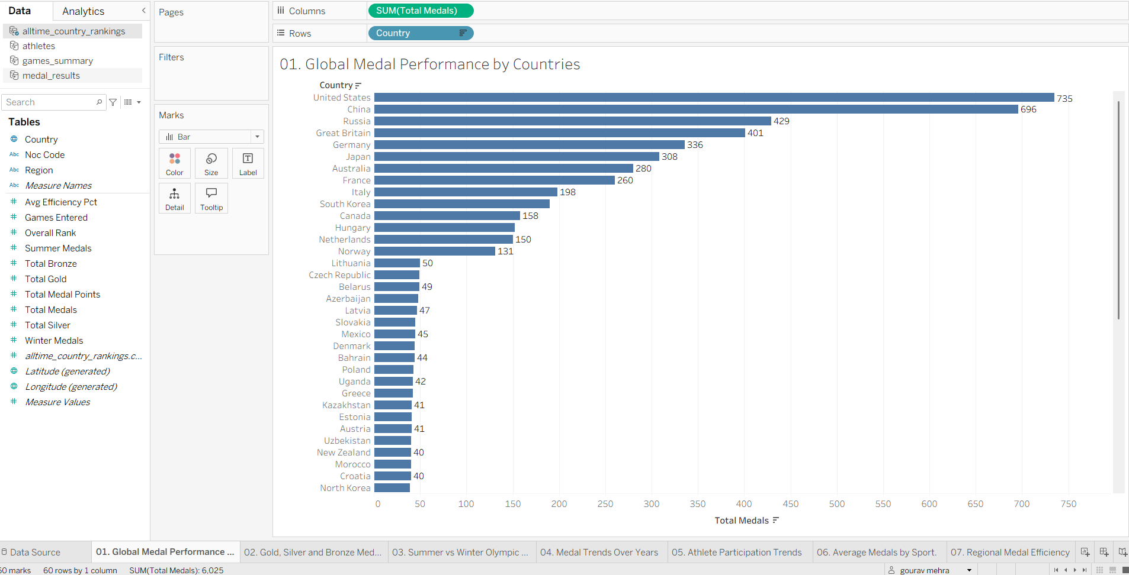
2 | Data Preprocessing | Fields are typed correctly in Tableau (Country with geographic role, numeric measures such as Total Medals and Medal Efficiency Pct, text dimensions such as Region, Season and Sports Investment). Country and region names appear consistently in the charts (e.g., Europe and Europe/Asia kept as separate regions). Detailed null/duplicate counts were not captured as screenshots.  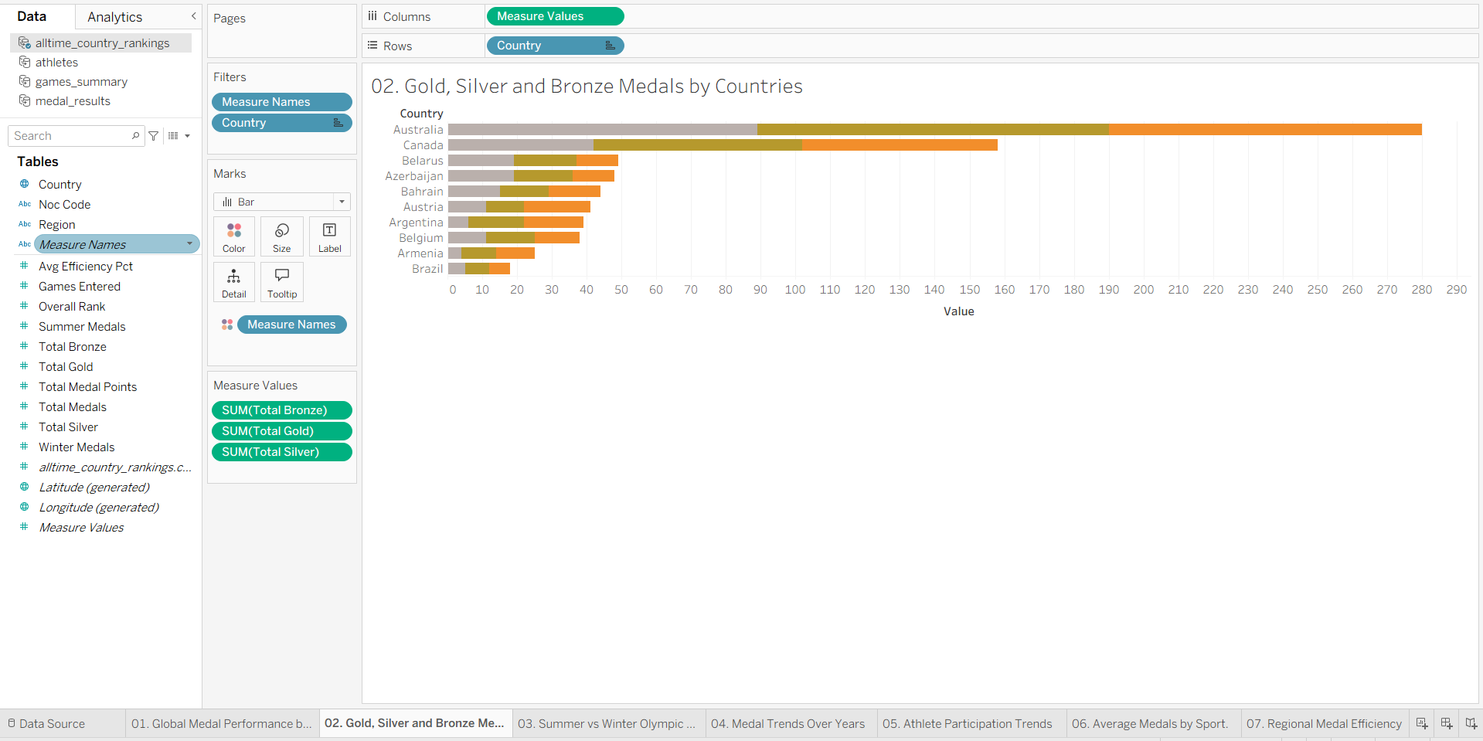
3 | Utilization of Filters | Filters used: Country filter (Sheets 2 and 3, sorted), Measure Names filter (Sheet 2), Host Nation filter (Sheet 9), and Season colour/legend on the trend views (Sheets 4 and 5).  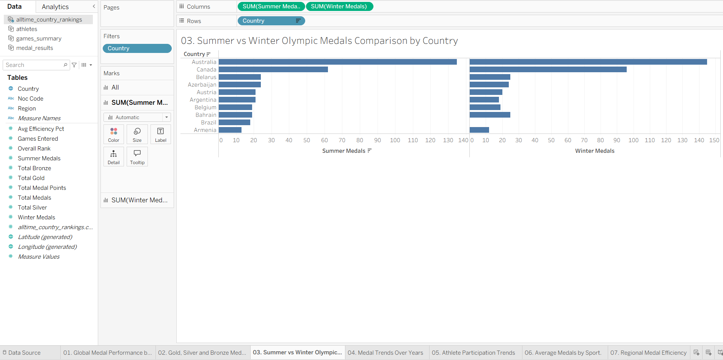  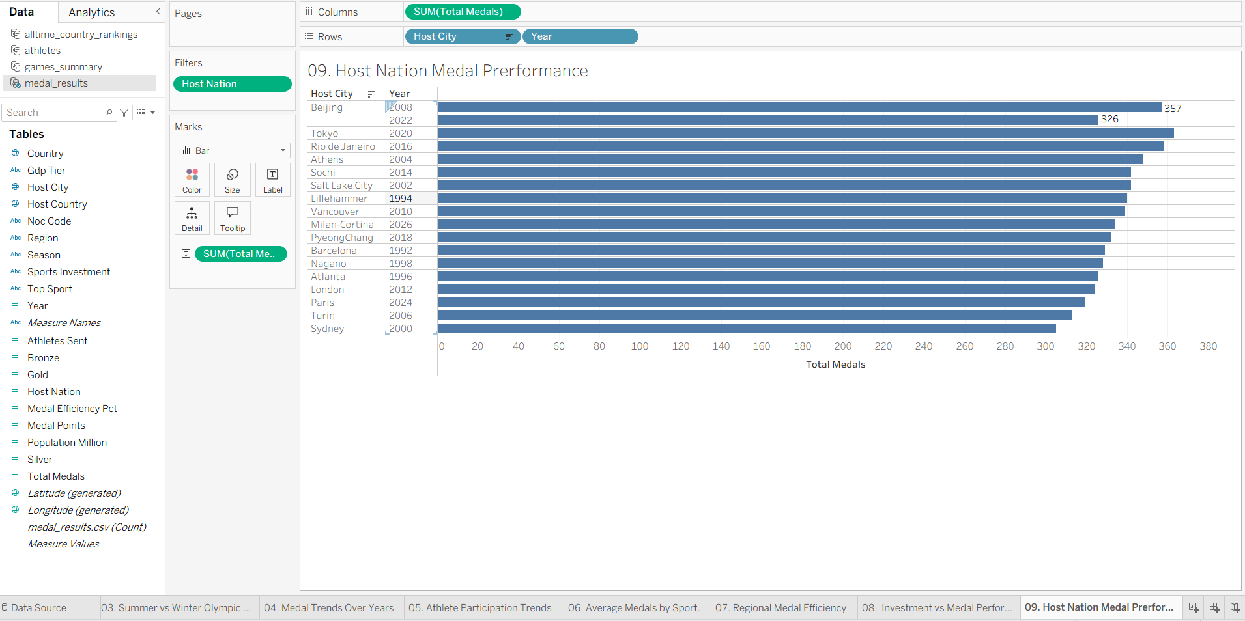
4 | Calculation fields Used | AVG(Total Medals) by Sport Category (Sheet 6); AVG(Medal Efficiency Pct) by Region (Sheet 7); AVG(Total Medals) by Sports Investment tier with Region as colour (Sheet 8). Aggregation shown on each shelf in the screenshots.  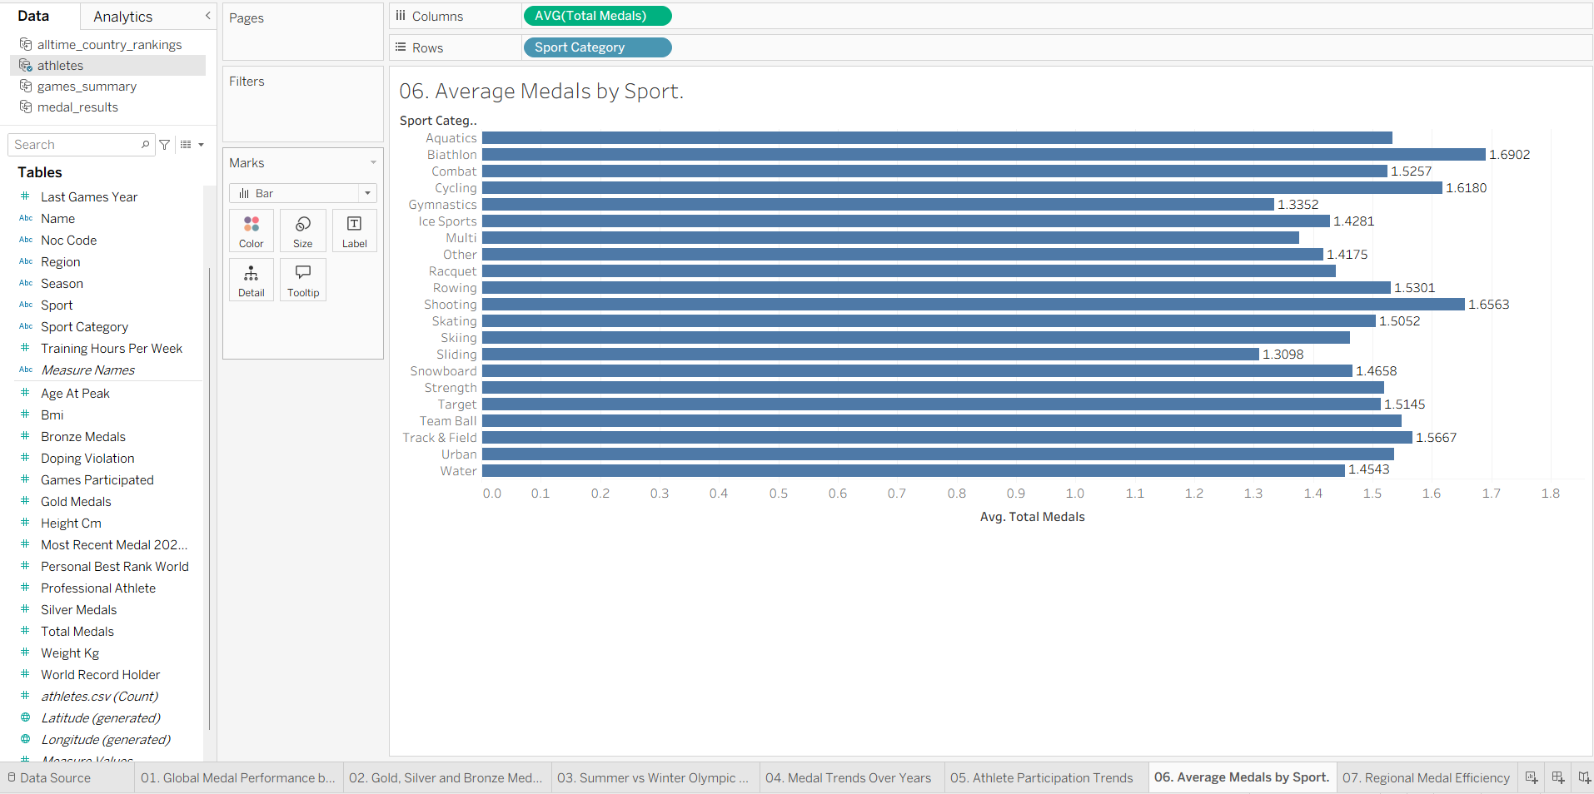  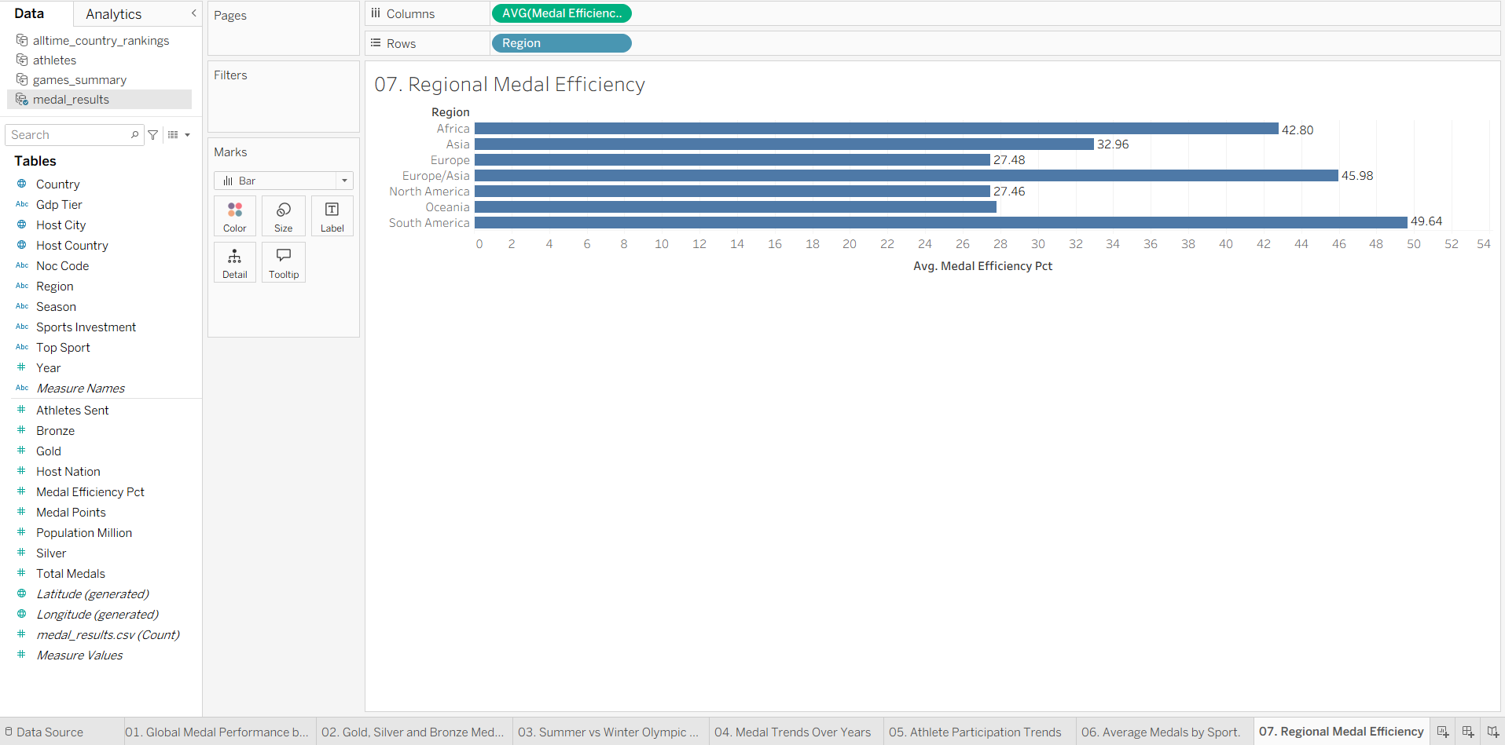  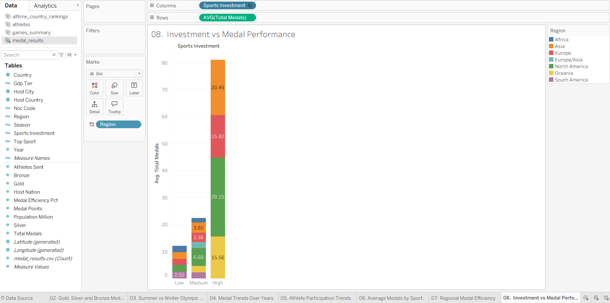
5 | Dashboard design | 3 dashboards built from the 9 worksheets (Dashboard 1 — Global Olympic Performance; Dashboard 2 — Sports Investment & Regional Efficiency; Dashboard 3 — Olympic Trends).  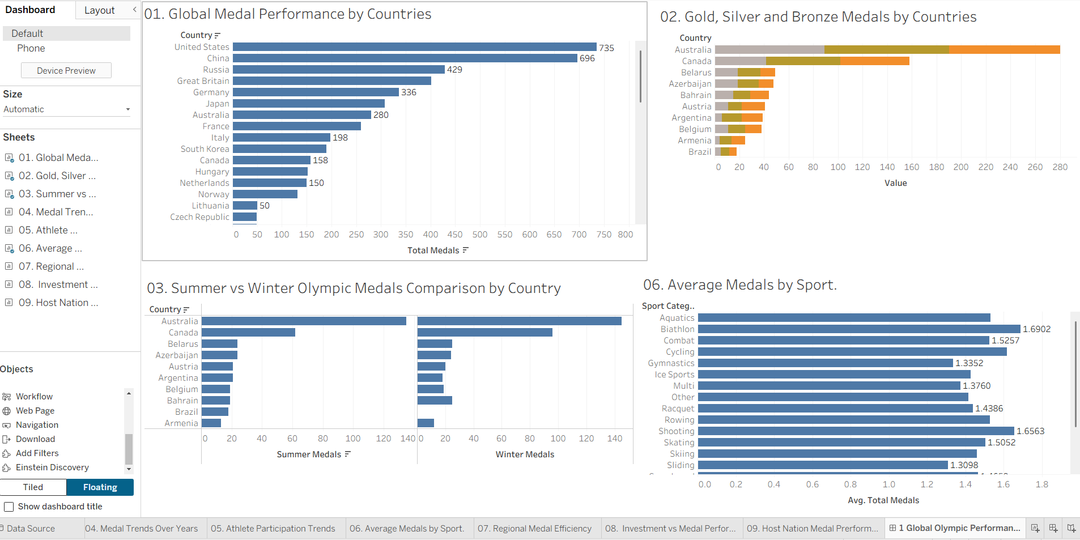  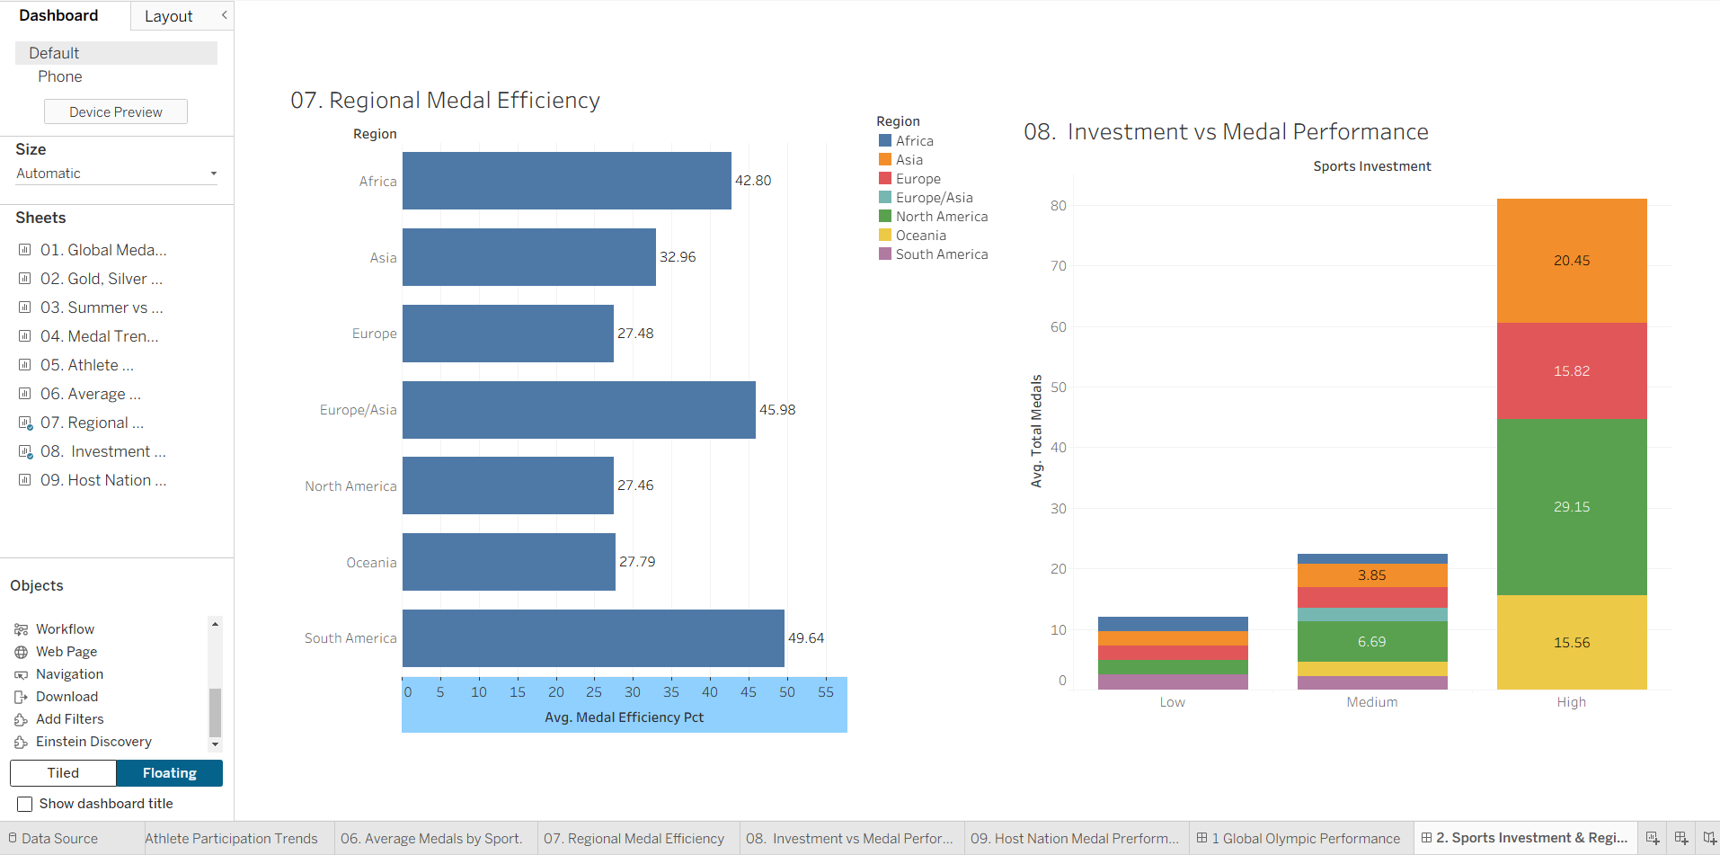  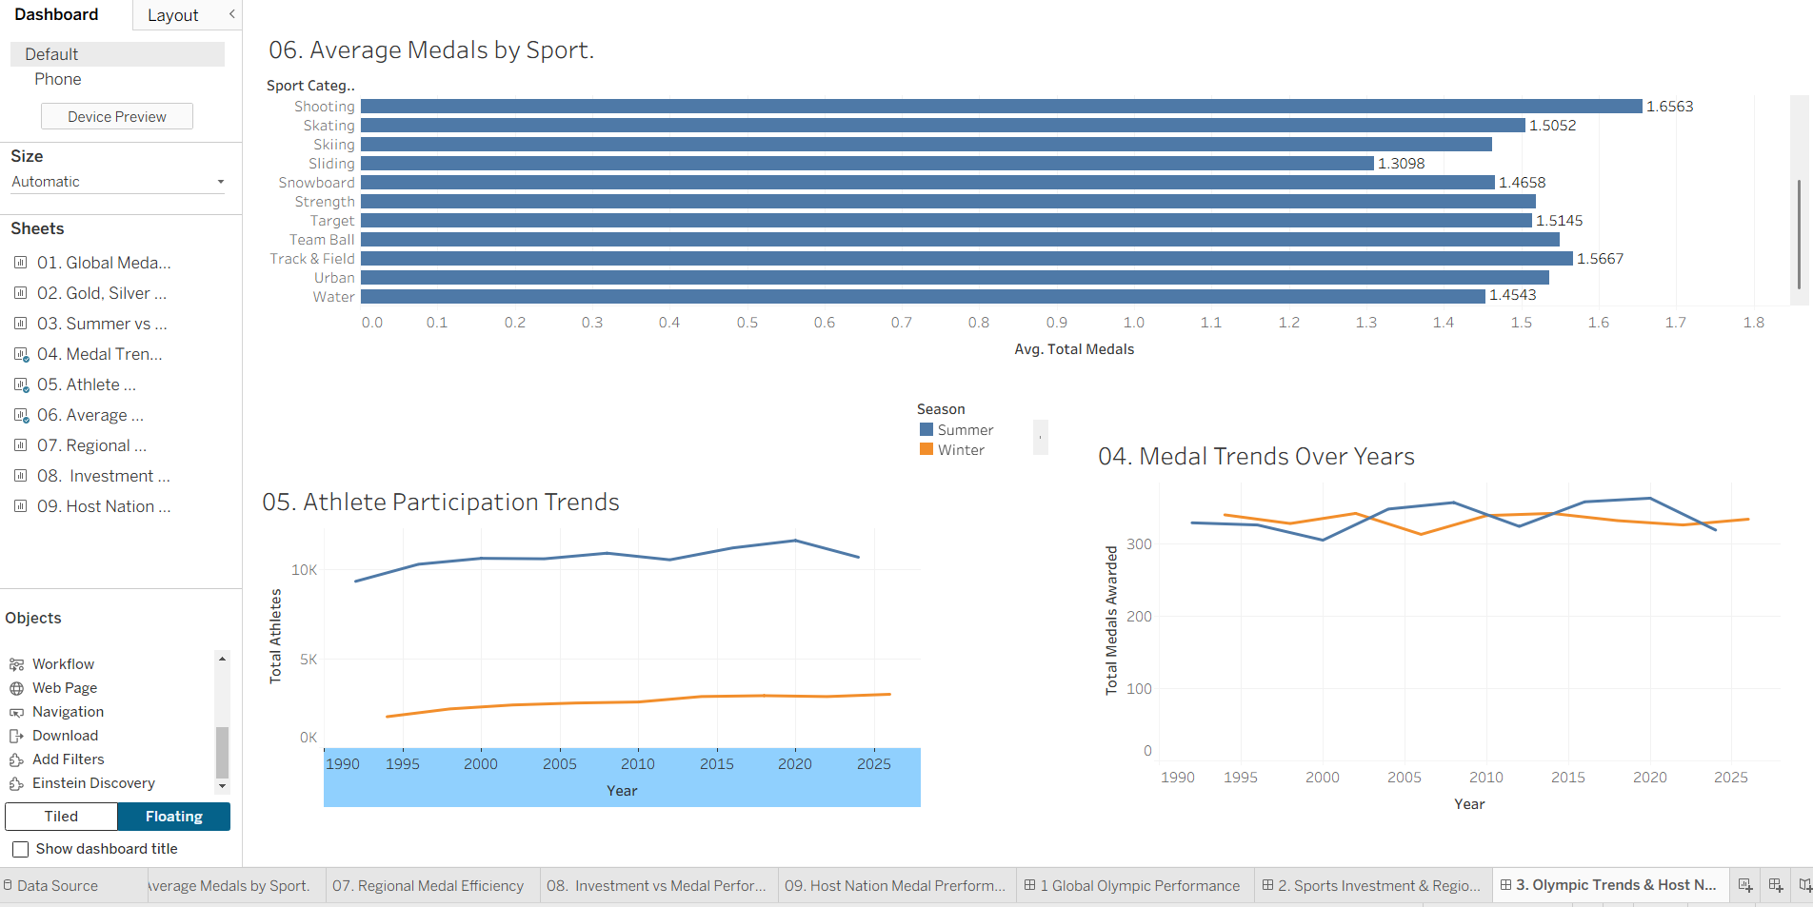
6 | Story Design | 1 Tableau Story, "Global Olympic Sports Performance Analysis — Story", with 3 story points (one per dashboard/scenario).  